### A PROJECT REPORT ON

**“TITLE OF PROJECT”**

Submitted for fulfillment of award of the degree

**BACHELOR OF TECHNOLOGY**

**(Computer Science & Engineering)**

**BY**

Team members Name (enrollment no )

**Under the guidance of**

<Guide Name>



**Department of Computer Science and Engineering**

### MIT School of Computing

### MIT Art, Design and Technology University, Pune

### MAEER’s Rajbaug Campus, Loni-Kalbhor, Pune 412201

**November, 2023**



**MIT SCHOOL OF COMPUTING**

DEPARTMENT OF COMPUTER SCIENCE & ENGINEERING

MAEER’s Rajbaug Campus, Loni-Kalbhor, Pune - 412201

**CERTIFICATE**

This is to certify that the project report entitled

### “PROJECT TITLE”

Submitted by

Team Members name (enrollment no)

is a bonafide work carried out by students under the supervision of Prof. ………….and it is submitted towards the fulfillment of the requirement of MIT-ADT University, Pune for the award of the degree of Bachelor of Technology (Computer Science & Engineering )

*(Two blank spaces)*

(Prof. Dr.________________) (Prof. Dr_______________)

Guide Co-Guide

(12, Sentence case)

Prof. Dr. Reena Pagare Prof. Dr. Rajneeshkaur Sachdeo

Project Coordinator Professor & Head of the Department

Prof. Dr. Kishore Ravande

Principal

Seal/Stamp of the College

Place : Date :

**[P-3](On Company Letter head/seal)**

**CERTIFICATE** (16, bold/upper case)

*(Three blank spaces)*

This is to certify that the project report entitled (12, sentence case)

*(One blank space)*

**“ YOUR DISSERTATION TITLE GOES HERE”** (12, bold/upper case)

*(Two blank spaces)*

Submitted by

*(One blank space)*

Name of the Candidate Exam No: ---------------------

(12, Title case)

*(One blank space)*

is a bonafide work carried out by him/her (with the Sponsorship from -------------------) under the

supervision of Mr/Ms/Miss. ………………………….. and has been completed successfully.

*(Four blank spaces)*

(Mr. ……………… )

(Designation)

External Guide

(12, Sentence case) Seal/Stamp of the Company/College

Place :

Date :

**DECLARATION**

We, the team members

| Name | Enrollment No |
| --- | --- |
|  |  |
|  |  |

Hereby declare that the project work incorporated in the present project entitled “Collaborative Framework for Information Diffusion in Online Social Network” is original work. This work (in part or in full) has not been submitted to any University for the award or a Degree or a Diploma. We have properly acknowledged the material collected from secondary sources wherever required. We solely own the responsibility for the originality of the entire content.

Date:

**Name & Signature of the Team Members**

**Name & Signature of the Guide**

Seal/Stamp of the College

Place : Date :



**DEPARTMENT OF COMPUTER SCIENCE & ENGINEERING**

**MIT SCHOOL OF ENGINEERING,**

**RAJBAUG, LONI KALBHOR,**

**PUNE – 412201**

**EXAMINER’S APPROVAL CERTIFICATE**

The project report entitled **“EXPERIMENTAL INVESTIGATION ON SELF CURING CONCRETE USING CURING AGENTS”** submitted by **SHELKE KARAN RAJKUMAR (MITU17MTSE0021)** in partial fulfilment for the award of the degree of **“Bachelor of Technology ( Computer Science & Engineering) ”** during the academic year 2019-20, of **MIT-ADT University, MIT School of Engineering, Pune,** is hereby approved.

**Examiners:**

**1.**

**2.**

**ACKNOWLEDGEMENT**

I express my profound thanks to my Guide **_____________** for her expert guidance, encouragement and inspiration during this project work.

I would like to thank **Dr. Reena Pagare**, Project Coordinator, Department Computer Science & Engineering for extending all support during the execution of the project work.

I sincerely thank to **Prof. Dr. Rajneeshkaur Sachdeo**, Head, Department of Computer Science & Engineering, MIT School of Engineering, MIT-ADT Univer- sity, Pune, for providing necessary facilities in completing the project.

I am grateful to **Prof. Dr. Kishore Ravande**, Principal, MIT School of Engi- neering, MIT-ADT University, Pune, for providing the facilities to carry out my project work.

I am thankful to **Prajakta Kashalkar**, DevOps Lead, IBM PureApplication, IBM India, Pune, **Pallavi Singh**, Senior Software Engineer, IBM India, Pune, as well as **Sanjay Singh**, Cloud Engineer, IBM Cloud Orchestrator, IBM India, Pune for guiding me to carry out my project work.

I also thank all the faculty members in the Department for their support and advice.

**Name, Enrollment No.**

**Abstract**

**KEYWORDS:** Information Diffusion, Online Social Network, Community Detection, Topic

Modelling, Trend Detection, Influential Nodes

| **CONTENTS** | | | |
| --- | --- | --- | --- |
|  | Certificate | | I |
|  | Declaration | | II |
|  | Acknowledgment | | III |
|  | Abstract | | IV |
|  |  | |  |
|  | List of Figures | | VII |
|  | List of Tables  List of Notations | | VIII  IX |
|  | **Contents** | |  |
| I | INTRODUCTION | |  |
|  | 1.1 | Introduction | 1 |
|  | 1.2 | Existing Work | 4 |
|  | 1.3 | Motivation | 7 |
|  | 1.5 | Objectives | 12 |
|  | 1.6 | Scope | 12 |
|  | 1.7 | Summary | 14 |
| II | CONCEPTS AND METHODS | |  |
|  | 2.1 | Dataset | 16 |
|  | 2.2  2.3 | Basic Definitions  Method /Algorithms / Models ……..  ……. |  |
| III | LITERATURE SURVEY  *[discuss at least 10 papers (IEEE transaction papers, Elsevier, Springer, ACM etc.)* | |  |
| ………….. |  |  |  |
|  | 3.5 | Research Gap | 37 |
|  | 3.6 | Problem Definition | 39 |
| IV | 4.1  4.2 |  |  |
| V |  | //SOFTWARE REQUIREMENT SPECIFICATION  *( Objective, Scope, Functional Requirement, Non-Functional Requirements, UML diagrams – Use case , DFD , Activity diagrams (compulsory) others are optional* ) ………….  ………….  ……….. | 40 |
| VI | PROPOSED METHOD | |  |
|  | 6.1 | Formulation | 51 |
|  | 6.2 | Overview | 52 |
|  | 6.3 | Framework Design  ……….. | 53 |
|  |  | ( *Mathematical model , proposed system architecture* ) |  |
|  | 6.4 | Result and Analysis ( *Screenshots , Graphs*) |  |
|  | .6.4.1 | Metrics | 63 |
|  | 6.4.2 | Dataset | 64 |
|  | 6.4.3 | Analysis | 65 |
|  | 6.5 | Summary | 75 |
| VII | 7.1  7.2 | Software Testing  Types of testing used  Test cases and results  PROJECT PLAN  Project Schedule  Project Cost Estimate | 77 |
| VII | CONCLUSION AND FUTURE WORK | | 80 |
|  | BIBLIOGRAPHY | | 83 |
|  | Annexure A : Publications Details (first page of paper publication)  Annexure B: Laboratory assignments on Project Cost estimation, Mathematical modelling, testing.  Annexure C : Plagiarism Report | | 93 |

List of Figures

| Figure 1.1 | Selection of Social Network for proposed research…………………….. | 14 |
| --- | --- | --- |
| Figure 2.1 | Illustration of various social connections on Twitter…………………… | 17 |
| Figure 2.2 | Graph Representation of Labelled Graph and Adjacency matrix……… | 17 |
|  |  |  |
| Figure 2.3 | Degree of Distribution………………………………………… | 21 |
| Figure 3.1 | Social Network Information Diffusion………………………… | 22 |
| Figure 4.1 | Collaborative Framework Design……………………………. | 43 |
|  |  |  |
|  |  |  |
|  |  |  |
|  |  |  |
|  |  |  |
|  |  |  |
|  |  |  |
|  |  |  |
|  |  |  |
|  |  |  |
|  |  |  |
|  |  |  |

List of Tables

| Table 5.3 | Coverage Rate ……………………………………………………. | 54 |
| --- | --- | --- |
| Table 5.4 | Topic distribution ………………………………………………… | 55 |
| Table 5.5 | Top hashtag related to topics……………………………………… | 57 |
| Table 6.1 | Cohesiveness of users…………………………………………….. | 66 |
| Table 6.2 | Analysis of structure of Communities formed (average)………… | 67 |

**CHAPTER 1**

**INTRODUCTION**

The social influence in a network can be identified through tracking communities and studying the behavior in the community. (Kempe et al., 2003) (Bharathi et al., 2007) Social influence was studied in context of influence maximization where method was proposed to find the nodes in the network who will increase the spread of information in the community and hence in the network. (Bonchi 2011)(Domingos & Richardson 2001). Their work highlights the social diffusion model and marketing strategies for various applications. The work of (Leskovec et al., 2007) also relates to study of how one person influences the other person for buying of products. Work is also done in to increase this influence as to increase the spread of information in the network. Social Influence is defined as the force put on a person due to her influencer and homophily is considered as the tendency that the other inactive node or person will follow the active node or influencer. (Goyal et al., 2010)(Saito et al., 2008)(Chen et al., 2010) (Xiang et al., 2010).

(Catadeli et al., 2011) uses the PageRank algorithm (Page et al., 1998) to assess the distribution of influence throughout the network. The PageRank value of a given node is proportional to the probability of visiting that node in a random walk of the social network, where the set of states of the random walk is the set of nodes.

**CHAPTER 4**

**PROJECT PLAN**

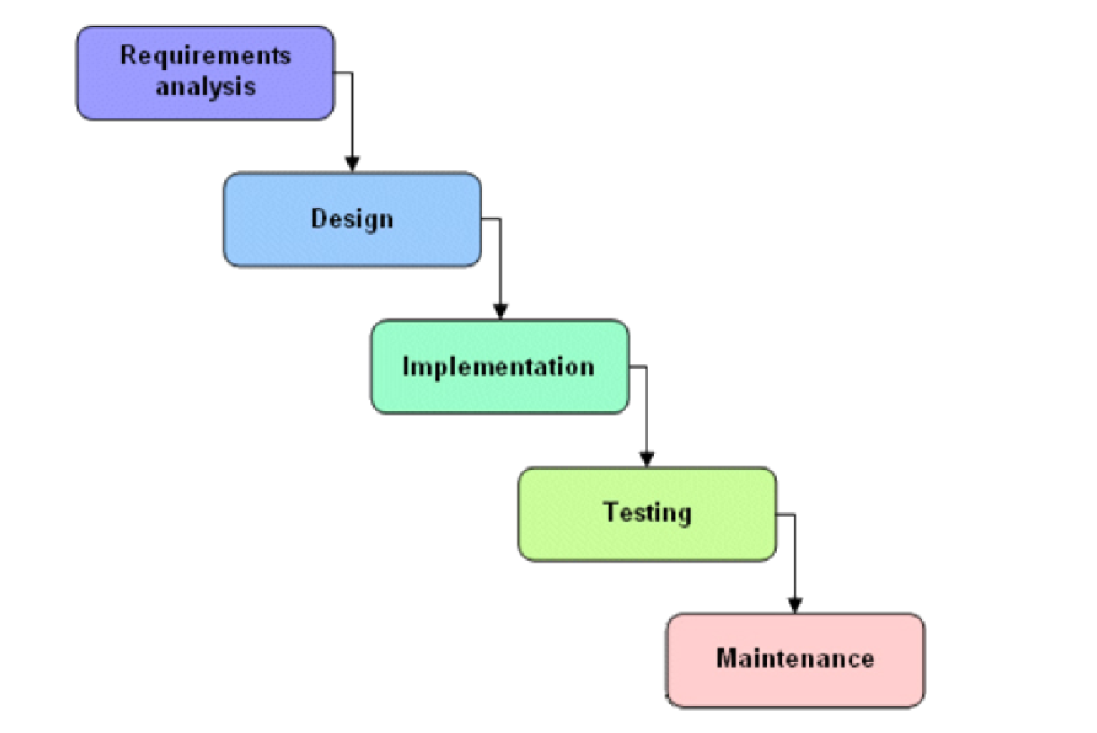

Figure 4.1: Project Plan

We approached the system development using the waterfall model depicted in the Based on this model, the required estimates have been stated in Annexure. In order to map our estimates with the steps in waterfall model, we considered each phase separately and then stated the required estimates.

**SAMPLE PROJECT PLANNER**

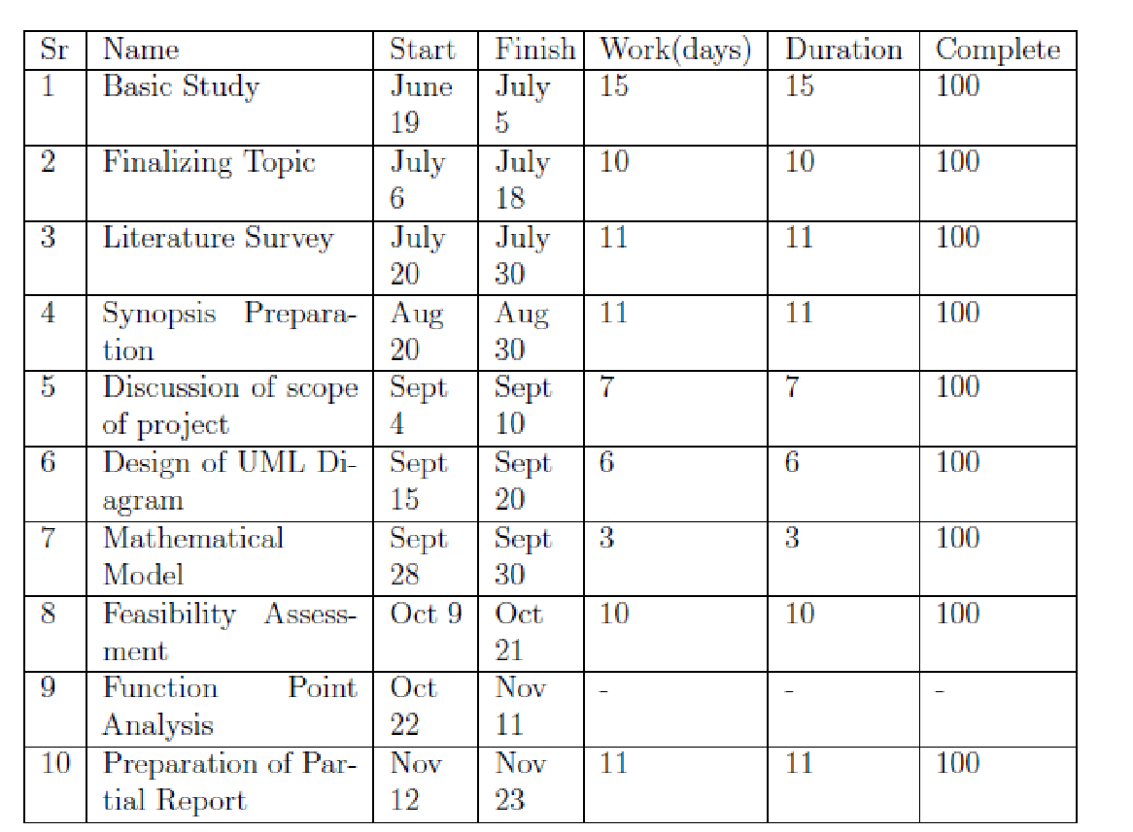

**Risk Analysis**

The risks for the Project can be analyzed within the constraints of time and Quality

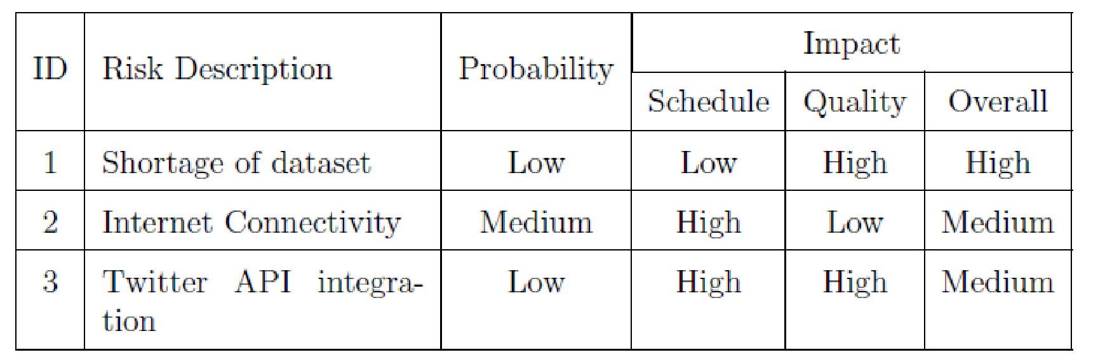

Table 4.1 : Risk table

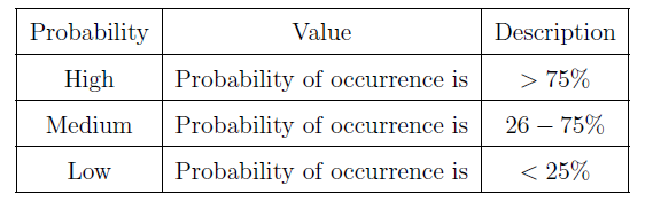

Table 4.2 : Risk probability definitions

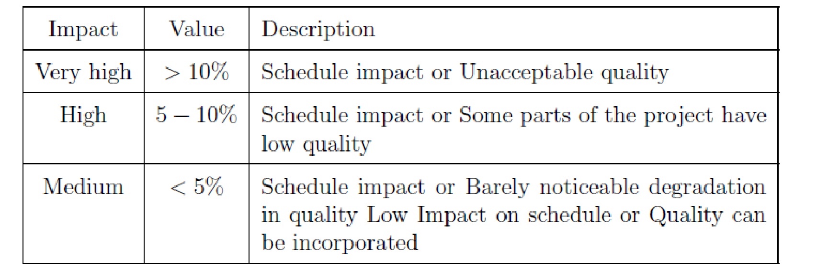

Table 4.3 : Risk impact definition

Following are the details for each risk.

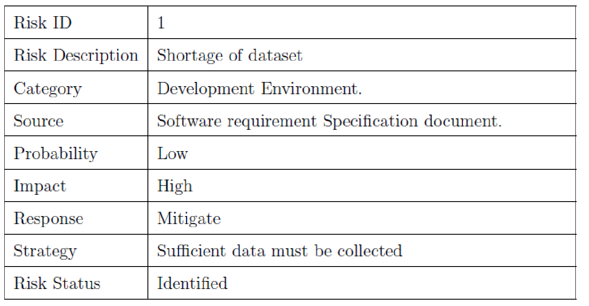

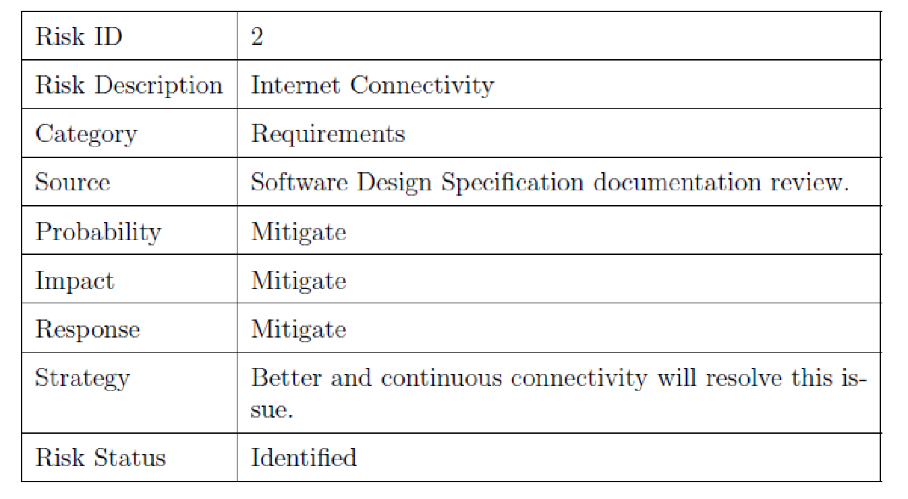

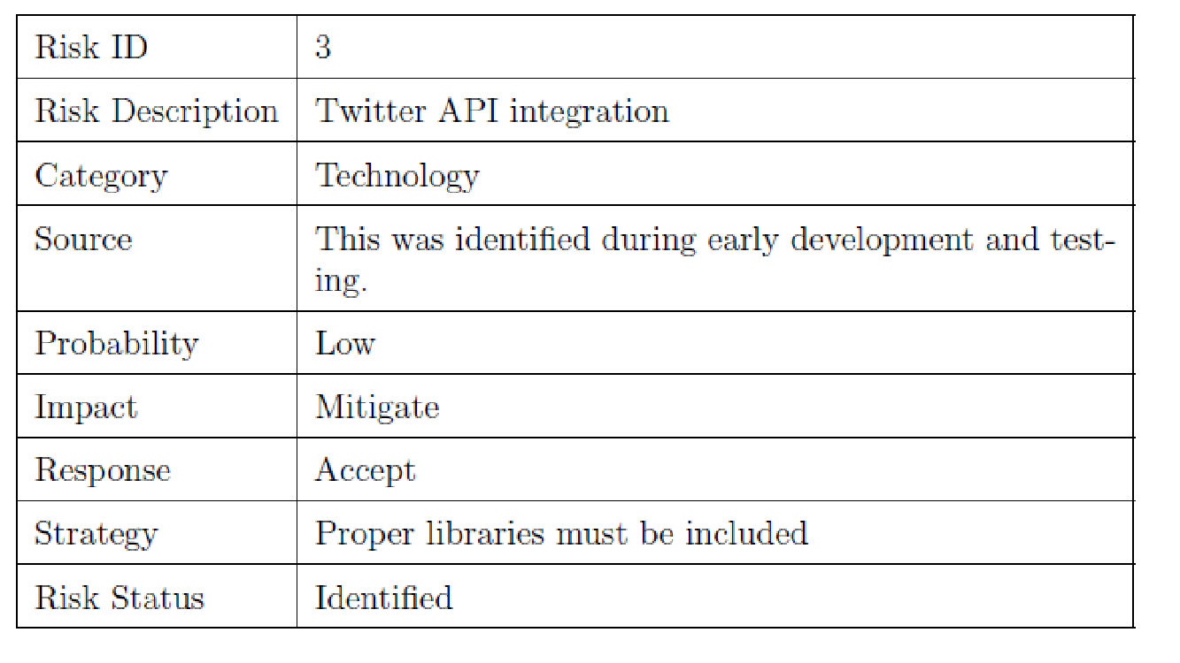

**CHAPTER**

**SOFTWARE TESTING**

**8.1** **Type of Testing Used**

1. Unit Testing

Unit testing, also known as component testing, refers to tests that verify the functionality of a speci_c section of code, usually at the function level. In an object-oriented environment, this is usually at the class level, and the minimal unit tests include the constructors and destructors.

These types of tests are usually written by developers as they work on code (white-box style), to ensure that the speci_c function is working as expected. One function might have multiple tests, to catch corner cases or other branches in the code. Unit testing alone cannot verify the functionality of a piece of software, but rather is used to ensure that the building blocks of the software work independently from each other.

2. Component interface testing

The practice of component interface testing can be used to check the handling of data passed between various units, or subsystem components, beyond full integration testing between those units.The data being passed can be considered as "message packets" and the range or data types can be checked, for data generated from one unit, and tested for validity before being passed into another unit. One option for interface testing is to keep a separate log _le of data items being passed, often with a timestamp logged to allow analysis of thousands of cases of data passed between units for days or weeks. Tests can include checking the handling of some extreme data values while other interface variables are passed as normal values.Unusual data values in an interface can help explain unexpected performance in the next unit. Component interface testing is a variation of black-box testing,with the focus on the data values beyond just the related actions of a subsystem component.

3. System testing

System testing, or end-to-end testing, tests a completely integrated system to verify that it meets its requirements.For example, a system test might involve testing a logon interface, then creating and editing an entry, plus sending or printing results, followed by summary processing or deletion (or archiving) of entries, then logo

**8.2 Sample test Cases**

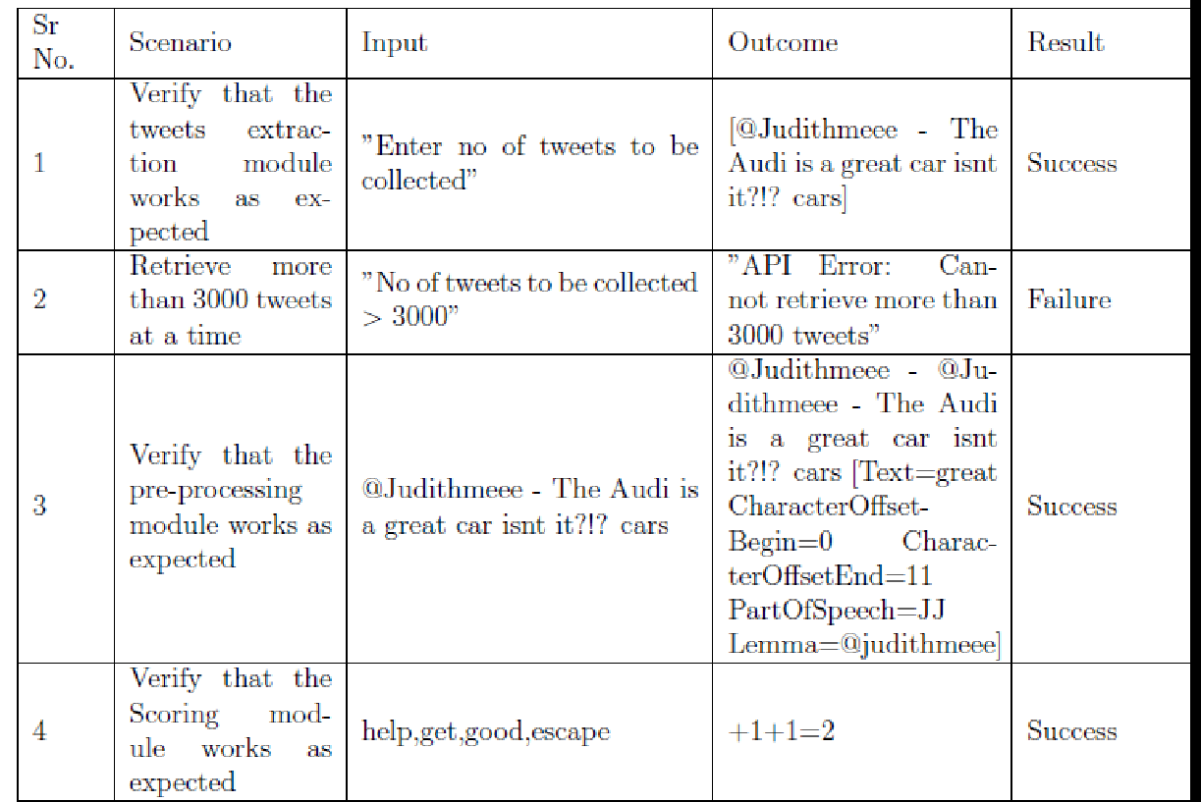

**CONCLUSION AND FUTURE WORK**

**BIBLIOGRAPHY**

A. Guille and H. Hacid. (2012), A predictive model for the temporal dynamics of information diffusion in online social networks, In WWW ’12 Companion, pages 1145–1152.

A. Pal and S. Counts. (2011), Identifying topical authorities in microblogs, In WSDM ’11, pages 45–54.

Alex Bavelas. (1950), Communication patterns in task-oriented groups, J. Acoust. Soc. Am, 22(6):725–730, Applications (pp. 115-146): Springer.

Azadeh Nematzadeh, Emilio Ferrara, Alessandro Flammini,Yong-Yeol Ahn.(2014), Optimal Network Modularity for Information Diffusion, Phys. Rev. Lett. 113, 088701 – Published 18 August 2014; Erratum Phys. Rev. Lett. 113, 259901.

B. W. Kernighan and S. Lin. (1970), An efficient heuristic procedure for partitioning graphs, In the Bell System Technical Journal, vol. 49, no. 2, pp. 291-307, Feb.  
*[doi:10.1002/j.1538-7305.1970.tb01770.x]*

James C. Bezdek. (1981), Pattern Recognition with Fuzzy Objective Function Algorithms, Kluwer Academic Publishers, Norwell, MA, USA.

Bharathi, S., Kempe, D. & Salek, M. (2007), Competitive influence maximization in social networks. Internet and Network Economics, pp.306–311.

Bonchi, F., (2011), Influence Propagation in Social Networks: A Data Mining Perspective. IEEE/WIC/ACM International Conferences on Web Intelligence and Intelligent Agent Technology, 2(1), pp.2–2.

**ANNEXURE**

**PLAGIARISM REPORT**